Quiz 03 學號： 姓名：

1. True or False: (1 points for each)
- In an intrinsic semiconductor, the number of free electrons is equal to the number of holes. (true)
- At room temperature, an n-type dopant provides an extra electron and a positively charged ion. (true)
- The depletion layer in a pn junction contains a large number of free carriers such as electrons and holes. (False)
- For a diode the piecewise linear model is a straight line modeled by a resistor and a voltage supply. (False)
- There are more free carriers available at low temperatures than there are at high temperatures. (False)
- Zener Diode is commonly operated under reverse bias. (true)
- The transfer characteristic shows the relationship between the output voltage and the input voltage for an electronics circuit. (true)
- The piecewise linear model for a diode with voltage less than forward drop voltage is a resistor and a voltage source. (False)
- For a P-N junction diode, the P represents Cathode and the N represents Anode. (False)
- In creating a depletion layer in the P-N junction electron diffusion current is from right to left. (False)

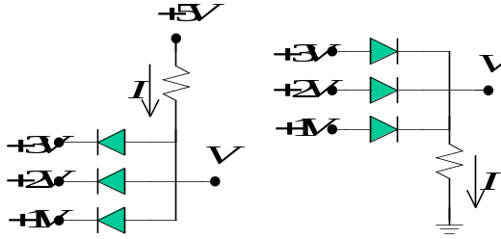
- Assume R= 1k, find the values of and 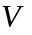 in the following circuits. (20 points)
Ans: Consider figure (1)
Only the diode applied +1V on 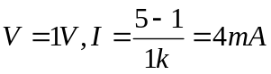
Consider figure (2)
Only the diode applied +3V on 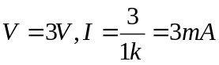
- Explain the physical operation of a PNP type transistor. (20 points)
- Consider the following NAND gate TTL circuit,
  - Let 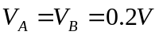 find 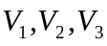 and  (10 points)
  - Let 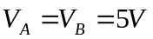 find and (10 points)
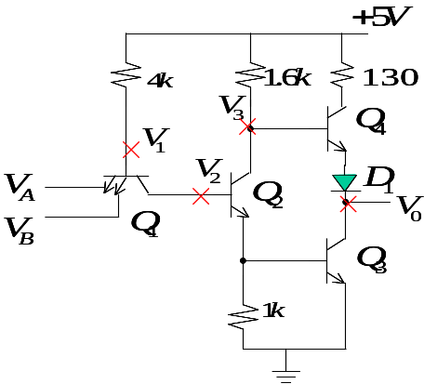
(a)
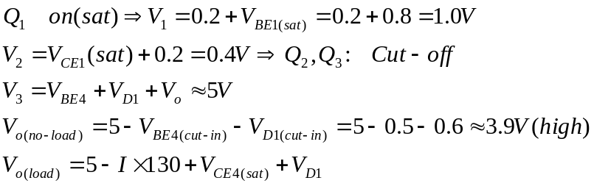
(b)
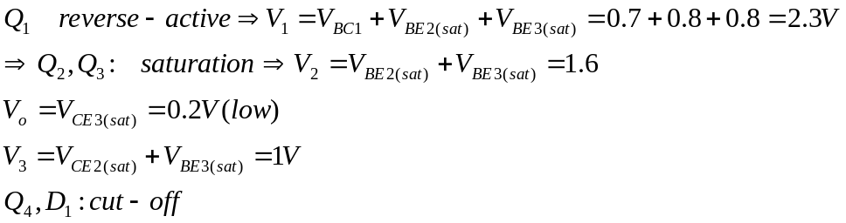
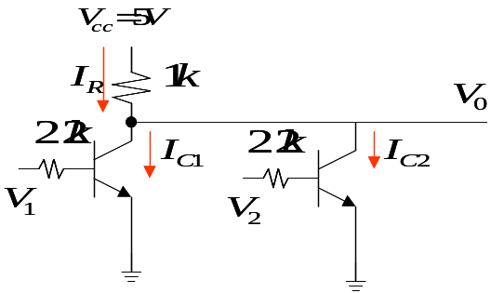
- Assume the transistor parameters are: 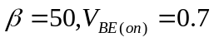and 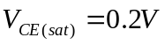. Determine the voltages and currents in the following circuit for various input conditions. (20 points)
 |  | 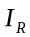 | 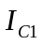 | 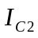
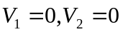 | 5V | 0 | 0 | 0
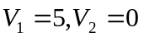 | 0.2V | (5-0.2)/1k=4.8mA | 4.8mA | 0
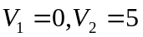 | 0.2V | 4.8mA | 0 | 4.8mA
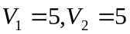 | 0.2V | 4.8mA | 2.4mA | 2.4mA

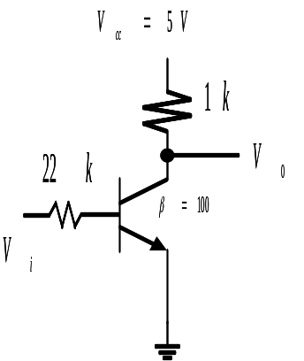
- Determine the DC voltage transfer characteristic curve of the following circuit. (10 points)
A:

